Modeling Project Proposal: Incubation Coordination in Leach’s Storm-petrels

Liam Taylor

*It takes one and a half parents to raise a [storm-]petrel chick*

-R.A. Mauck

*Introduction and Questions*

Birds of the order Procellariiformes are noteworthy for a suite of life-history traits and behaviors which flourish in a pelagic environment with high energetic costs and high energetic stochasticity. Many members of this order, including the Leach’s Storm-petrel (*Oceanodroma leucorhoa*; Fig. 1) exhibit a strict breeding strategy: large breeding colonies, single-egg clutches, long incubation and fledging periods, social monogamy, and obligate biparental care (Huntington et al. 1996). Some of these traits, such as colony nesting and clutch size, have been well-examined in a variety of ecological and evolutionary contexts (Lack 1947, Coulson 2001).

Obligate biparental care, perhaps as an operative subset of social monogamy, has remained less well understood. In the case of Leach’s Storm-petrels (and a variety of similar procellariforms), it is unclear how parents manage to raise an egg together. The rough energetic picture is well known (e.g., Ricklefs et al. 1980, Montevecchi et al. 1992), and these energetic demands give rise to the *obligate* character of the Leach’s Storm-petrel’s biparental care.

But what is the precise nature of that obligation? In other words, given that storm-petrel parents must care for an egg together, what behavioral strategies mediate the distribution of care between parents? Given the energetic demands of the parents and the egg, what behavioral strategies (i.e., what patterns of “coordination” between parents) are *necessary* and/or *sufficient* for reproductive success in this biological system?

Three hypotheses can be posed: (1) There is no coordination between parents, and the observed patterns of parental incubation are merely emergent properties of the system’s energetic character; (2) there is coordination between parents, but this coordination is limited to what each parent can learn about the other during brief overlapping visits that are themselves stochastic; (3) there is fuller, more responsive coordination, stemming from both overlapping visits and extra information parents glean about their partners on the foraging ground or through historical knowledge.

Past work has given rise to a set of information that could, from an abstract and qualitative level, support each hypothesis. For example, (1) Leach’s Storm-petrel eggs are particularly resilient to incubation “neglect” (pers obs.; see Boersma and Wheelwright 1979 for a closely-related species) suggesting that parents may be merely responding to the energetics of the system and letting the egg soak up sub-optimal scheduling results; (2) It is extremely rare that both parents are in the nests at the same time and, indeed, the size of the nests usually allows for only one parent to incubate at a time (pers. obs.). Thus, when one parent arrives, the previously-incubating parent leaves, suggesting at least a simple cue at the root of coordination; (3) Given that breeders share general foraging grounds with other members of their colonies (Hedd et al. 2018) and that strong olfactory cues may be used as recent-historical signals at the breeding site (Grubb 1974), there are a number of possible mechanisms that would allow for a more finely-tuned set of coordinated responses.

*Model*

These are all just...words, though (A. Sanchez, pers. comm.). Given the well-specified energetic dynamics of the system and a wealth of available data (see *Study Site*), I propose a quantitative model of incubation behavior in Leach’s Storm-petrels that tests the necessity and sufficiency of coordination behaviors between two parents caring for a single egg. This initial model has four states, and a respective set of transition functions among those states (Fig. 2).

In a model with no coordination, the probability of a nest being in a given state has simple exponential relationships to the transition functions. We can then assess this “dumb” null model: Does the probability that a nest is empty fit neatly within an egg’s empirical ability to withstand a lack of incubation? If so, we need not posit coordination behaviors. We can then turn to analyze the ways in which simple coordination behaviors (e.g., no “two-parent” state) alter the system in ways that give room to strategic social gaming on the part of the parents. In other words, we can begin to investigate how coordination could benefit future, rather than current, reproductive success.

If the null fails to function (i.e., the probability that a nest is left empty is higher than an actual egg could successfully withstand), we can alter the transition functions that dictate the rate at which parents leave the nest such that they shift as a function of distance from the previous “two-parent” state. The resulting dynamics would represent a simple coordination that operates through parent’s overlapping presence for brief periods within a nest. If, again, this level of coordination fails to provide realistic reproductive success, we can turn to other functions that respond more perfectly to the state of the nest, even when not passing through a “two-parent” state.

Though I will initially model two identical parents, sex-specific differences may be critical to the true dynamics of Leach’s Storm-petrel reproduction. In particular, current research suggests male-biased effort in incubation (Mauck et al. 2011, Mauck *et al.* in prep). By altering transition functions such that a “female” parent incurs a one-time cost of the egg, while the other, “male” parent does not, we can begin to parse out the ways in which male-biased incubation effort may emerge directly from the energetic environment or, alternatively, represent coordination-based behavioral strategies directly available to sexual selection.

Given the intuitively “discrete” nature of the system itself, I will use iterative simulations to numerically determine the behavior of this model. I plan to implement this model using C++ integrated with R, the latter of which will also be used for data wrangling, analysis, and visualization.

*Study Site and Parameterization*

The Leach’s Storm-petrel colony on Kent Island, New Brunswick, Canada, has been monitored each breeding season since 1953, representing the longest known continuous field study of a single wild population by an individual scientist (Wheelwright and Mauck 2017). Like other populations of Leach’s Storm-petrels, adult parents during the breeding season travel an average of 400+ km from the nesting site to reach their foraging grounds (Hedd et al. 2018), suggesting a strict “state-switch” decision for parents.

In addition to the long-term demographic data available on a study population of 100+ active yearly nests (including egg incubation periods, adult masses, and reproductive success of known parents), a preliminary study in 2015 directly monitored four actively breeding nests with Passive Integrated Transponder (PIT) tags (similar methods in Zangmeister et al. 2009) to produce real-time data on biparental incubation activity (e.g., Fig. 3). These data, as well as energetic data from this and other populations are available to parameterize the model. Should the model prove interesting, ongoing field studies can be designed around measuring key parameters or testing key insights.

**References**

Boersma, P. D., and N. T. Wheelwright. 1979. Egg neglect in the Procellariiformes: reproductive adaptations in the Fork-tailed Storm-Petrel. Condor 81:157–165.

Coulson, J. C. 2001. Colonial breeding in seabirds. Pages 100–127 Biology of marine birds. CRC Press.

Grubb, T. C. 1974. Olfactory navigation to the nesting burrow in Leach’s petrel (*Oceanodroma Leucorrhoa*). Animal Behaviour 22:192–202.

Hedd, A., I. L. Pollet, R. A. Mauck, C. M. Burke, M. L. Mallory, L. A. M. Tranquilla, W. A. Montevecchi, G. J. Robertson, R. A. Ronconi, D. Shutler, S. I. Wilhelm, and N. M. Burgess. 2018. Foraging areas, offshore habitat use, and colony overlap by incubating Leach’s storm-petrels *Oceanodroma leucorhoa* in the Northwest Atlantic. PLOS ONE 13:e0194389.

Huntington, C. E., R. G. Butler, and R. A. Mauck. 1996. Leach’s Storm-Petrel (*Oceanodroma leucorhoa*). The Birds of North America Online.

Lack, D. 1947. The significance of clutch-size. Ibis 89:302–352.

Mauck, R. A., J. L. Zangmeister, J. C. Cerchiara, C. E. Huntington, and M. F. Haussmann. 2011. Male-biased reproductive effort in a long-lived seabird. Evolutionary Ecology Research 13:19–33.

Montevecchi, W. A., V. L. Birt-Friesen, and D. K. Cairns. 1992. Reproductive energetics and prey harvest of Leach’s storm-petrels in the northwest Atlantic. Ecology 73:823–832.

Ricklefs, R. E., S. C. White, and J. Cullen. 1980. Energetics of postnatal growth in Leach’s Storm-Petrel. Auk 97:566–575.

Wheelwright, N. T., and R. A. Mauck. 2017. Charles Ellsworth Huntington, 1919–2017. Auk 135:158–159.

Zangmeister, J. L., M. F. Haussmann, J. Cerchiara, and R. A. Mauck. 2009. Incubation failure and nest abandonment by Leach’s Storm-Petrels detected using PIT tags and temperature loggers. Journal of Field Ornithology 80:373–379.

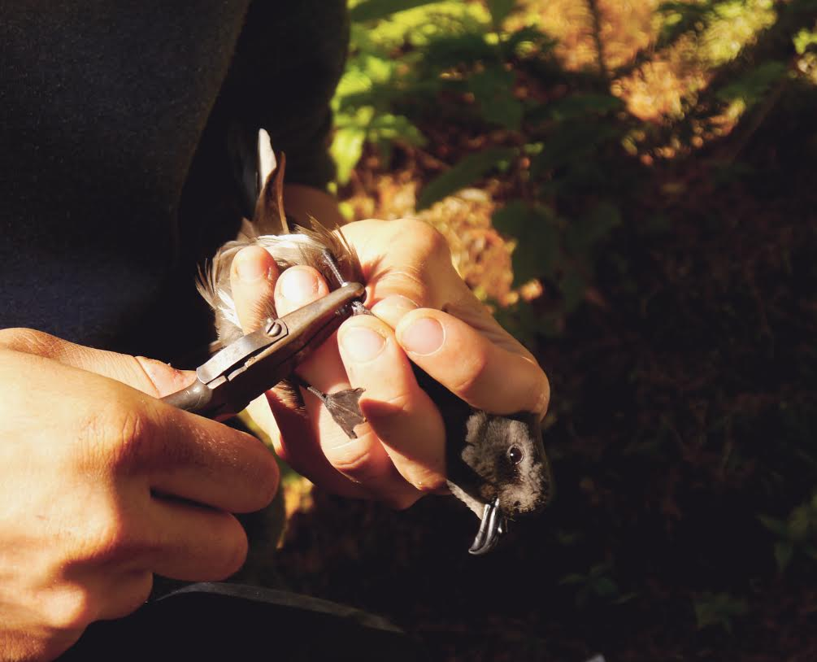

Figure 1. A ~~panicking~~ zen Leach’s Storm-petrel (*Oceanodroma leucorhoa*), ~~imprisoned~~ protected in the ~~panicking~~ loving hands of a ~~confused undergrad~~ future Yale EEB student.

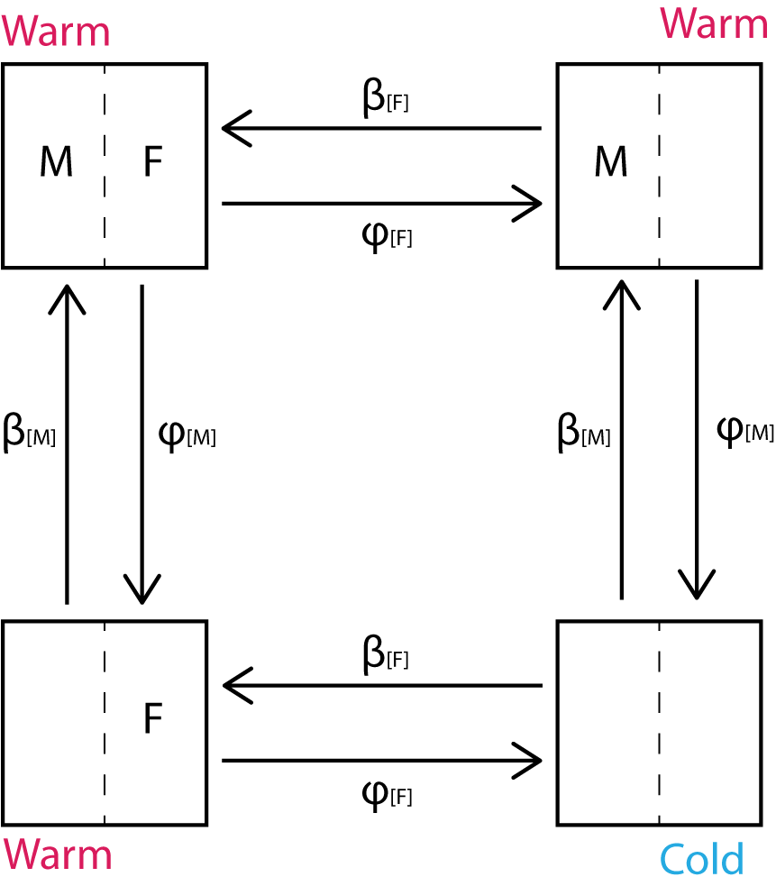

Figure 2. Preliminary model diagram for the Leach’s Storm-petrel incubation coordination model. Male (M) and female (F) parents transition between states according to β functions (which describe “returning to incubate” by stochastically sampling from a foraging energetics distribution) and φ functions (which describe “leaving to forage” by deterministically following an incubation energetics function). An egg is successful if it is sufficiently incubated by a parent (“warm”), and an egg can fail if it is left “cold” for too long.

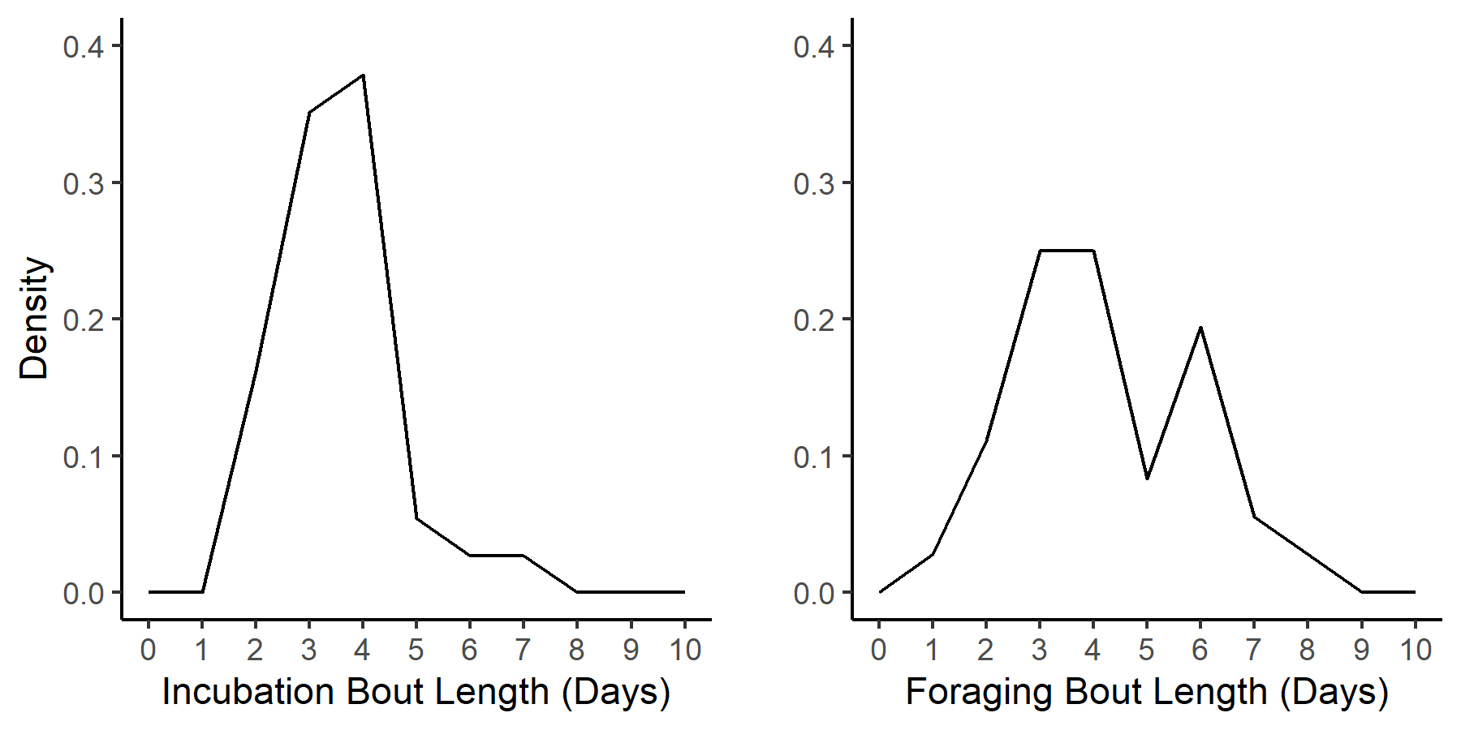

Figure 3. Preliminary results of real-time incubation activity monitoring of Leach’s Storm-petrels using Passive Integrated Transponder tags. *Left*: Density of consecutive days (“bouts”) of incubation in actively breeding adults (N=37 bouts). *Right:* Density of consecutive days of foraging (i.e., non-incubation) in actively breeding adults (N=36 bouts). Data were collected from 8 adults across 4 nests.